INTRODUCTION:

Our project consisted of designing a multirotor with four arms ,each of them with a motor at their ends. Quad copters are similar to helicopters in some ways, though their lift and thrust come from 4 prop rather than 1.

It also included designing a joystick capable of controlling the roll , pitch, yaw and throttle of the quad.

MOTIVATION:

Initially, Our motivation was to design a quadcopter for surveillance of inaccessible areas, controlled by a self-designed joystick which could give varied commands.

However , the first basic motive was to control the basic flight of the quad and stabilize it. Later , we aim at adding surveillance features to it.

CONCEPT AND PRINCIPLE OF WORKING:

The basic principle is that motors provide required thrust force using propellers (2 CW 2 CCW) lift the quadcopter. Since being 4 and arranged as shown in the figure the torque is balanced. The system developed uses a set of 3 angles to describe, in this case, the orientation of the quadcopter around the 3 spatial dimensions namely

1. Role
2. Pitch
3. Yaw

Ours is an x-model which differs from the + model in a few ways.

We considered the following advantages of the x over the + model , which motivated us to go for the chosen configuration:

* **Physics:** The vehicle will feel different to the operator even with the same motors and software settings. In more detail: when you do the math for controlling a quadrotor, the distance away from the axis of rotation determines the torque generated by the motors. Consider a quadrotor with each arm of length r away from the center of mass of the vehicle and think about one axis of motion (roll or pitch). If you have a "+" configuration, then the thrust forces are applied at a distance r. If you have an "x" configuration, then the thrust forces are applied at distance of r*cos(pi/4)  approximately 0.71*r since the arms are at a 45 degree angle from the axis of rotation. The moment of inertia is the same when you do the math, so the difference is really that you can torque with all four motors, and therefore have sqrt(2) more available torque to rotate. This means you can get about 41% more rotational acceleration from an "x" than a "+".
* **Visibility of Yaw:** A "+" will have one marked front arm. An "x" will have two. I think it is easier to establish your front arc with two front lights/marks, rather than one. Due to the frame shape and accessories, frequently the operator can only see two of the four arms on a quadrotor. If you have one uniquely colored arm and can only see two arms, that leaves an ambiguity as to which direction the vehicle is facing. This is personal preference, but recovering situational awareness during flight is a very safety critical process.
* **Camera Arc Clearance:**An "x" can have a camera pointed forward without obstruction from the frame more easily than a "+". Some designs remove this concern, either by mounting the camera on a standoff or with moving landing gear.

**Components used in the Project :**

1. **BLDC MOTORS(4):**

These are bladeless DC motors with high torque to weight ratio. They have more efficiency compared to brushed DC motors.

* + 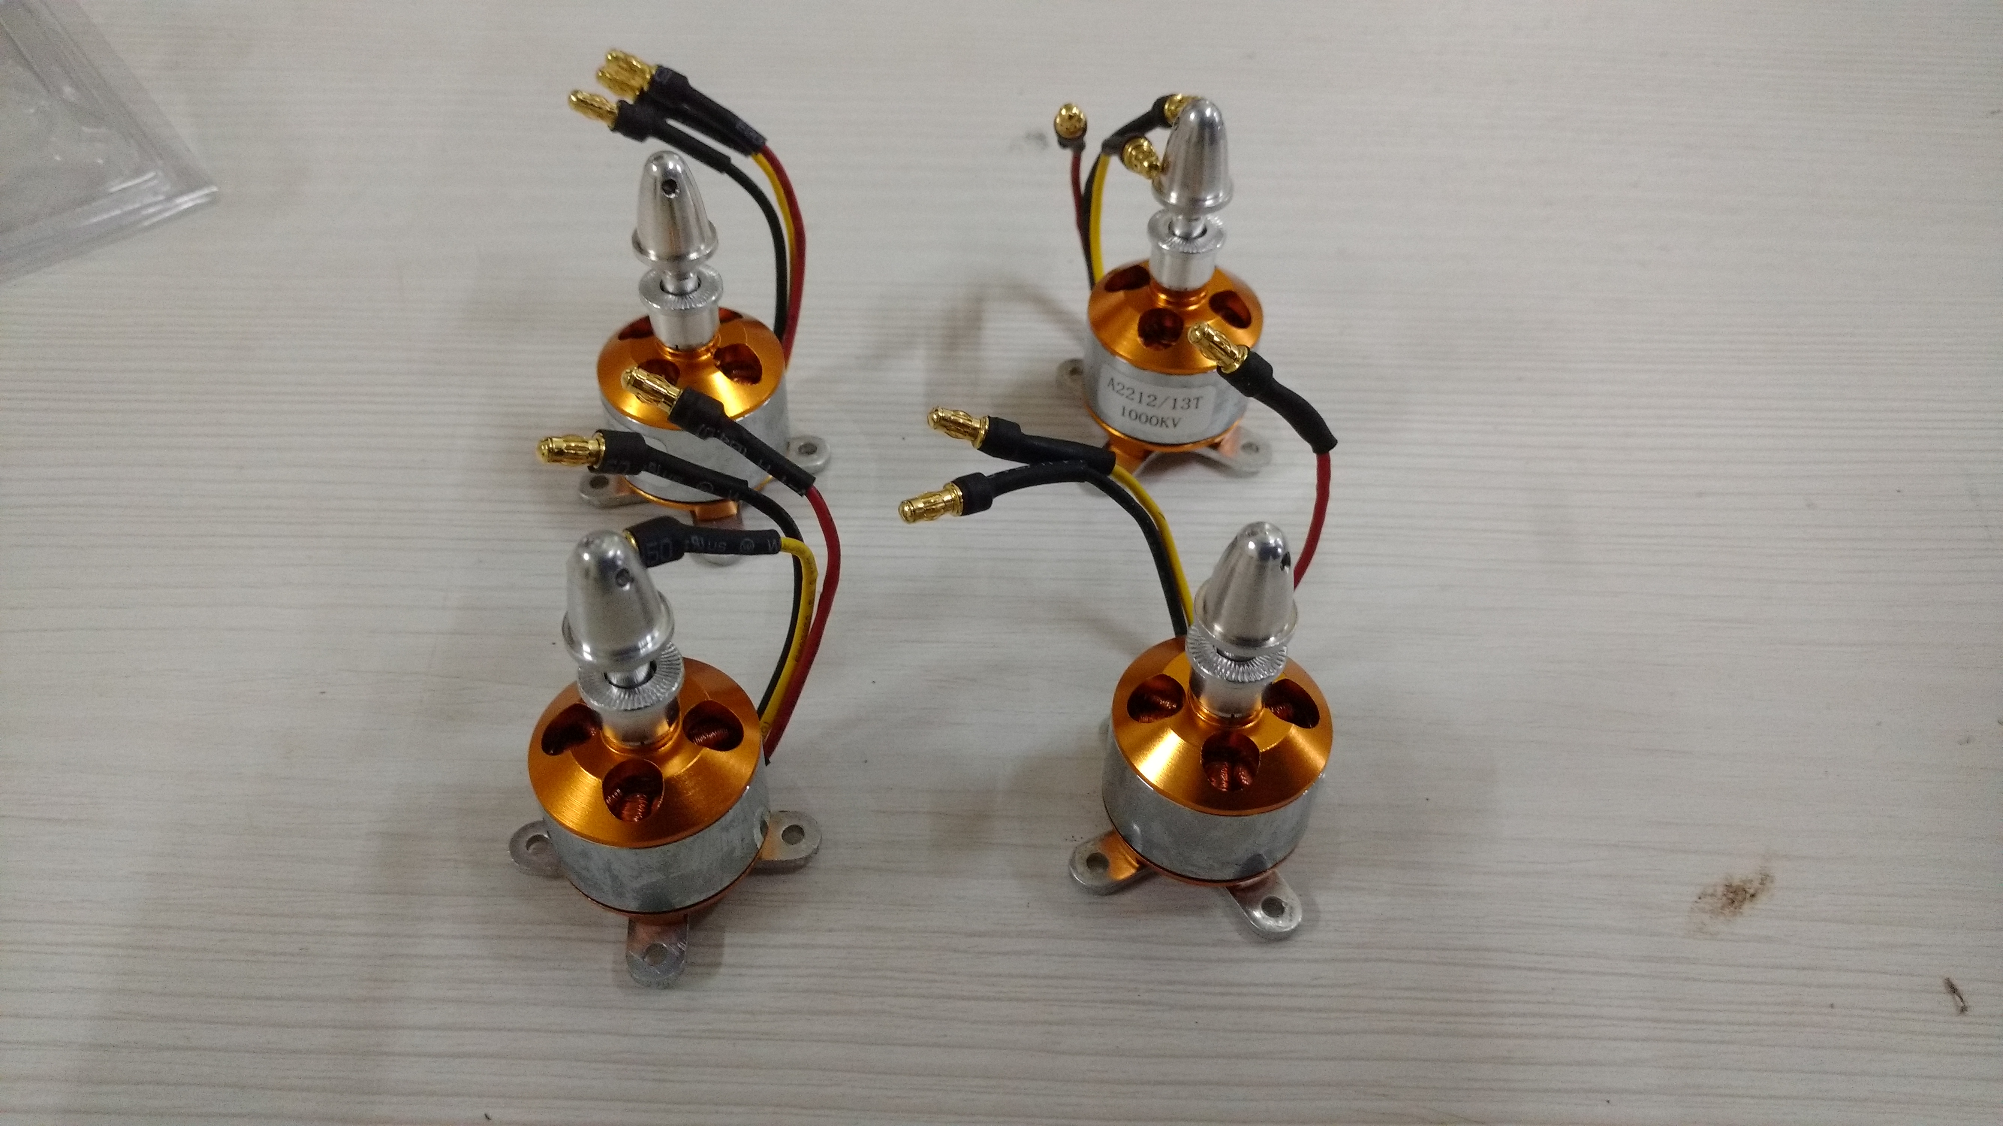

1. **ESC(ELECTRONIS SPEED CONTROLLER)(4):**

An electronic speed control or **ESC** is an electronic circuit with the purpose to vary an electric motor's speed, its direction and possibly also to act as a dynamic brake.

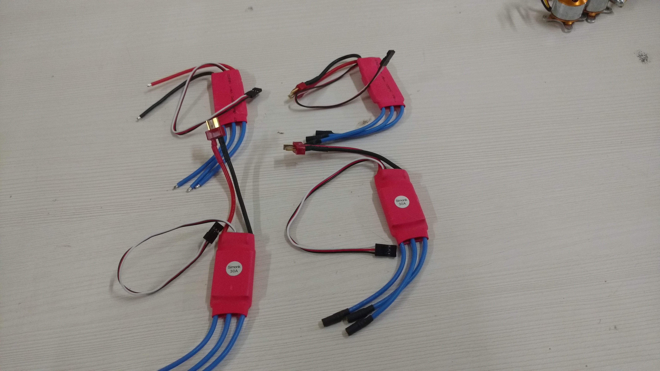

**3. nRF24l01(transceiver module)(2):**

We used these for communication between joystick and the quadcopter.

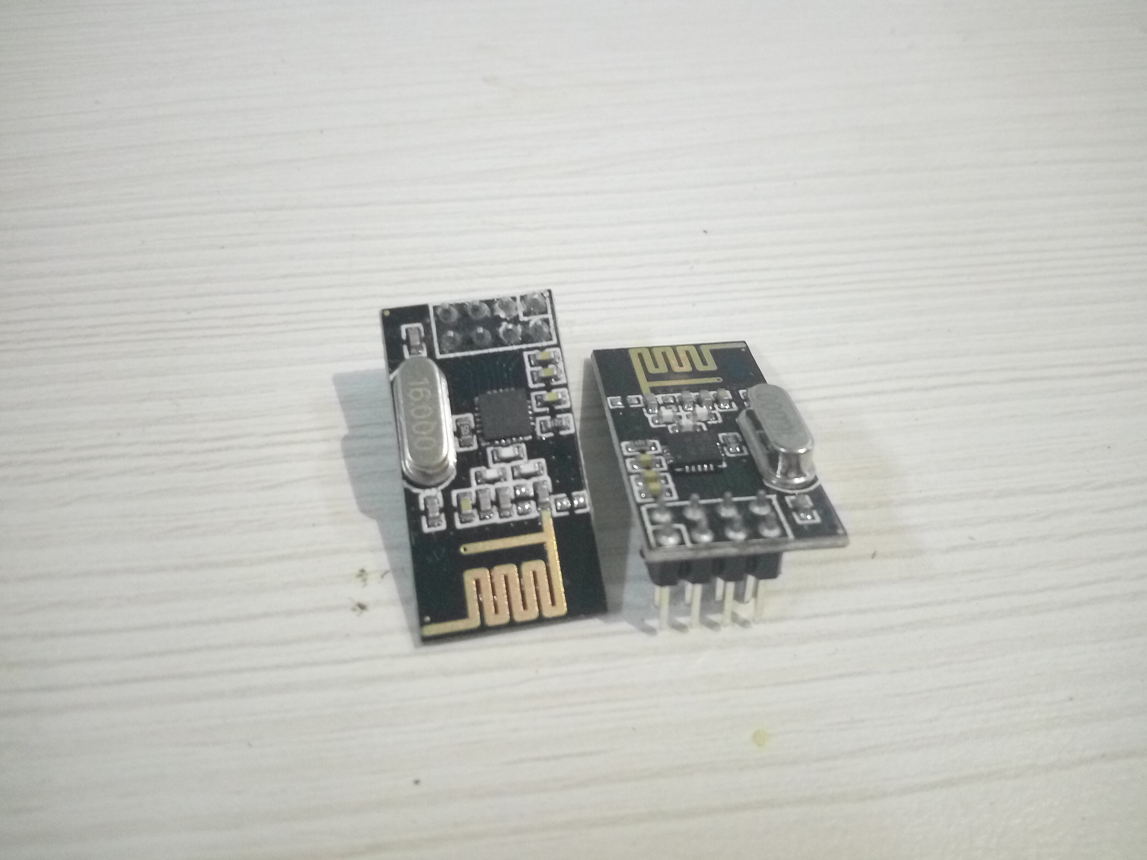

**4. Arduino (uno and nano):**

**Arduino** is an open-source electronics platform based on easy-to-use hardware and software. **Arduino** boards are able to read inputs - light on a sensor, a finger on a button, or a Twitter message - and turn it into an output - activating a motor, turning on an LED, publishing something online.

We used the uno for the quadcopter(requiring more pins) and the nano for the joystick.

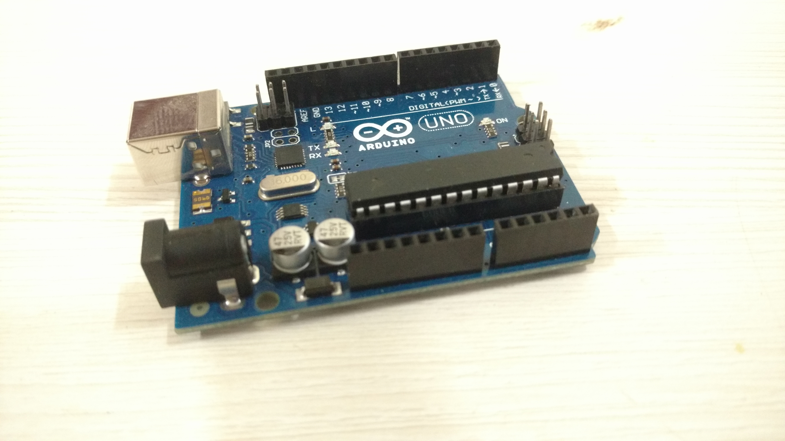

**5. Gyroscope:**

We used GY-521 Mpu6050 Module for our project which provided an inbuilt 3-axis gyro+accelerometer

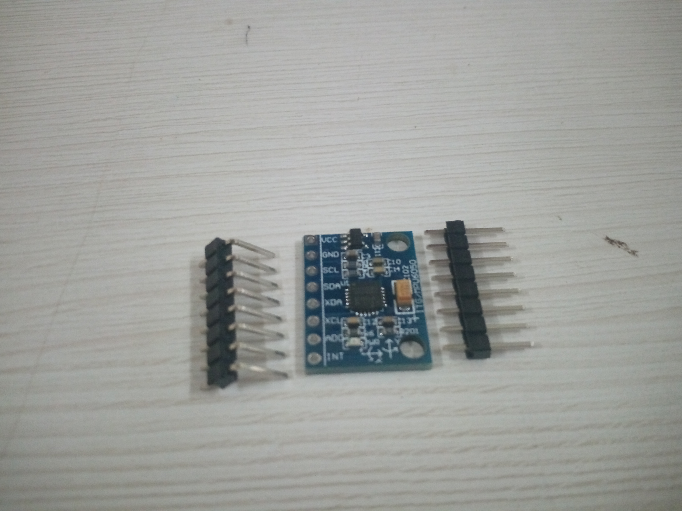

# 6. JOYSTICK MODULE:

# Any joytick module can be used for a self-programmable joystick. We used Robo India RI-09 Thumb Joystick Module.

# 

# 7. BATTERY:

# Battery requirement depends on the motor requirement.

# We calculated the required battery rating using this calculator.

# We used the Wolfpack White 4200mah 20C 11.1V battery ordered online.